**Final Project Report: 2022 WLUNA Crash Detection**

**BIA 658 Social Network Analysis**

May 05, 2023

Amna Shamshad, Kanika Yadav, Sreelekha Kotla, Praveena Thalupunuri

# EXECUTIVE SUMMARY

This report provides useful analysis of crypto coin WLUNA Crash 2022 by using ERC2O transaction data provided on Stanford website. The nodes act as the users and the edges are the transactions. Analyzing the social network involving WLUNA transactions, this report provides interesting findings that can be used to predict a future crash by exploring the network properties like centralization, degree , modularity and transitivity of the network. The evident changes in the social network are highlighted by analyzing the network before and after the crash. Effects of any significant effects of homophily have also been explored by looking for the tendency of nodes with higher degree to form bonds with nodes having a high degree. The results from this model showed that users with higher connections were not more likely to be connected to each other prior to crash. Ergm was used to test for significance of density of the network prior to the crash using April data. The density was significant in April. It means that the network was well connected in April. The results of the network analysis indicated that a decreasing network density, higher centralization and higher transitivity can be a sign of an upcoming crash creating a “domino effect” in the network. The network is most centralized when WLUNA price reaches close to zero causing a significant fraction of transactions to be done by a group of users. This panic selling results in a drastic decrease in price of a coin. Since we had data for 6 coins, a correlation has also been explored in order to find out any dominant relation between WLUNA and any other coin. In future if the value of a USTC increases, investors can also think about buying WLUNA to possibly boost returns because of high correlation.

# INTRODUCTION

Stablecoins help the crypto economy by providing liquidity. This reports analyzes the social network that involves transactions of WLUNA, whose data is derived from the Terra Network dataset containing transactions of six stable coins.USDT

* USDC
* DAI
* UST
* PAX
* WLUNA.

We have explored the network properties for Luna network to answer the question.

***“To what extent can Luna crash be detected by exploring the network properties of the Terra network?”***

# DATA UNDERSTANDING

The data shows the amount of stablecoin transmitted between different users. Each **user** has a **unique address**. Each **coin** has a unique **contract address**. The initial dataset comprised over 70 million transactions (till November) out of which we have worked on data from Friday, April 1, 2022 11:10:21 AM GMT) to Monday, August 31, 2022 12:00 AM GMT). The Luna crash occurred on 12th of May, 2022 when its price reached 0 USD. The closing daily price data for each coin was present in a separate file.The time data was in seconds (epochs) and was converted to proper datetime format using python. In the network constructed, **Crypto users are nodes and** **transactions are the edges.** The network was constructed from an edge list that consists of 2 columns of nodes (from_address and to_address) and the weight of the edge that corresponds to the number of transactions between the two users.

# NETWORK ANALYSIS

We have used various social network concepts to analyze our dataset. Following approaches have been used to study the social network to detect and analyze WLUNA crash.

* Graphical analysis of network for various months before and after WLUNA crash
* Comparison of transitivity, reciprocity and centralization prior and post crash
* Correlation between the six crypto coins
* Checking for homophily effects in social network prior crash
* Comparison of network modularity before and after crash
* Comparison of price stats for various month
* Effects of various events on the price of WLUNA coin.

## GRAPHICAL ANALYSIS OF NETWORK BEFORE AND AFTER CRASH

The network that was taken for analysis consists of nodes representing users. The weight of the edges defines the amount of transactions between two users. The more the transactions, the greater the weight. The timestamp column was converted into proper format using R and then data for each month was saved into a separate csv file. Data was segregated month wise and a separate network was constructed to analyze the data. The actual crash data was 12th May, when WLUNA hit 0. Four months have been taken into consideration namely April, May , June and July. The WLUNA networks of the various months have been shown below. The networks have been visualized using Gephi by importing the data as edge list. In order to do so, only the columns, from_address, to_address and weights were used as Source Target and Weights respectively.

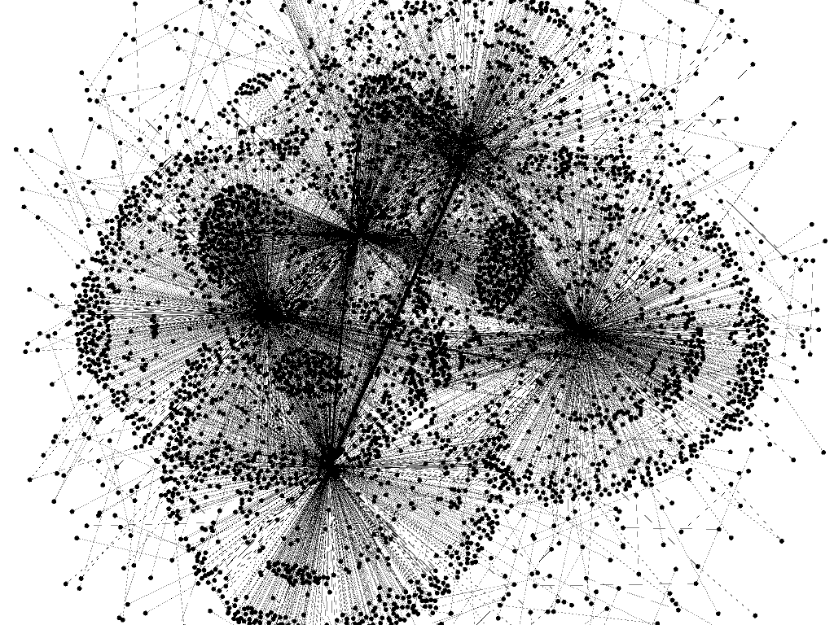*WLUNA Network in April*



*WLUNA Network in May*

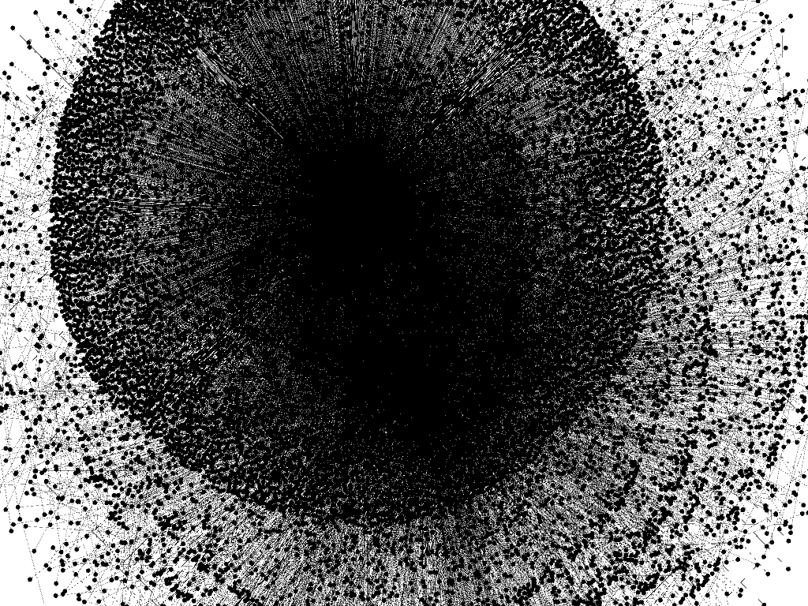

*WLUNA Network in June*

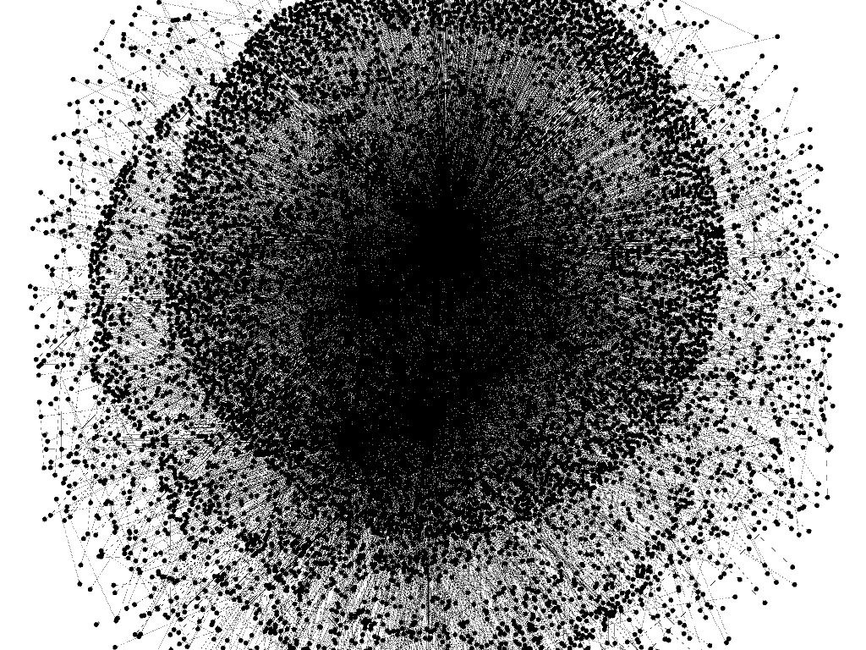*WLUNA Network in July*

It can be seen from the graphs that the network becomes very centralized in May. The graph is not very centralized in April as compared to May, June and July . As the WLUNA price started dropping constantly, it created havoc in the market. Certain hubs of users can be seen making more transactions than usual. There can be two main reasons for that.

1. *Users who had invested in WLUNA started selling WLUNA in order to save their money when the price started dropping consistently*
2. *Users started buying WLUNA because of the low price in the hope that they’ll get huge profit once WLUNA recovers back to its original price.*

## Comparison of Transitivity, Centralization, Reciprocity

Following network properties have been analyzed to compare the WLUNA network before and after crash. There are 5 months that have been taken into consideration. The results below verify the graphs shown above and indicate that the network centralization was highest in May. The following important observations can be deduced from the results below.

* Network density was highest before crash as the users are highly connected to each other
* Network was less centralized before crash as the users transactions exhibit a random network
* Network transitivity was highest before crash
* In May, the prime month of shock for WLUNA purchasers, the transitivity dropped considerably low.
* The reciprocity is low before and during crash but slightly increases after May

Users formed isolated clusters or cliques, rather than being interconnected across the network. This resulted in a fragmented network with limited opportunities for information diffusion and collaboration. One of the reasons for low transitivity can be a lack of shared interests among the network's members. That’s because there were users who had invested in WLUNA coins and then there were users who had not invested in WLUNA coins. As the WLUNA price started dropping, the ones who had invested in WLUNA started selling WLUNA and the ones who had not invested much in WLUNA did not make any considerable amount of transactions involving WLUNA. Higher centralization accounts for the panic selling. In the start of May, when WLUNA prize started dropping, it resulted in panic selling, major investors who had invested in WLUNA sold the coin because of which the coin crashed and reached the prize of 0 USD on 12th of May.

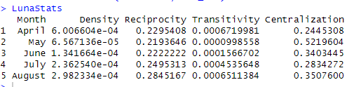

One thing to be noted is that the price of WLUNA didn't jump to zero directly. It kept on dropping constantly till it dropped zero as shown in the graph below.

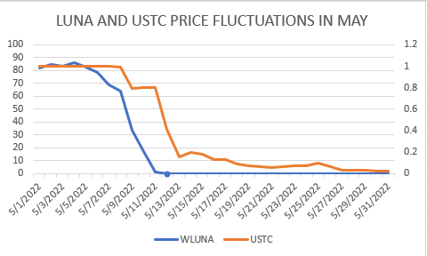

*WLUNA and USTC Price Fluctuations in May*

So in order to deeply analyze the behavior of users forming the network, we further divided our network into three smaller networks. The file containing records of May was divided into three smaller data frames to construct three networks as shown below.

1. May (01-08)
2. May(09-12)
3. May(13-31)

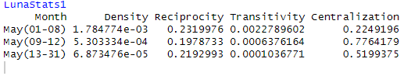

The following observations have been derived from the stats above.

* The density of the network keeps on decreasing with decreasing price. It means that a number of users decreased their transaction activities due to the unstable market.
* The fluctuations in reciprocity are not very significant
* Transitivity of the network keeps on decreasing with decreasing price. There were lesser triangles to be formed in the network prior to the crash.
* The network is most centralized when the WLUNA price reaches close to zero causing a significant fraction of transactions to be done by a group of users. With the key players in the network coming together, the network, insider trading starting with the groups of individuals.

## Correlation Between the Six Crypto Coins With Respect To Price

In order to find the correlation between cryptocoins with respect to price, we used the file that contains the daily closing price of each coin for the months of April, May, June, July and August. The data was then merged to find the correlation between six coins.

The results indicated that the highest correlation occurred between WLUNA and USTC. A high correlation between these two cryptocurrency coins indicates that they are closely related and tend to move in the same direction. In other words, when the value of one coin rises, it is likely that the value of the other coin will rise as well, and vice versa when the value of one currency falls.

Investment decisions in future may benefit from this correlation. For instance, if a trader thinks that the value of a USTC will rise, they can also think about buying WLUNA to diversify their holdings and possibly boost returns. It's crucial to keep in mind, though, that correlation does not necessarily imply causation, and other factors could potentially affect how much each cryptocurrency is worth.

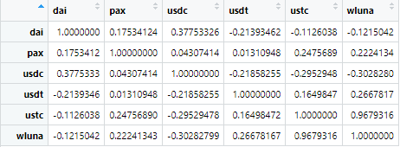

*Correlation Matrix Between 6 Crypto Coins*

The results shown above can be further verified with the graph below. The graph shows the prices of 6 coins during the month of May.

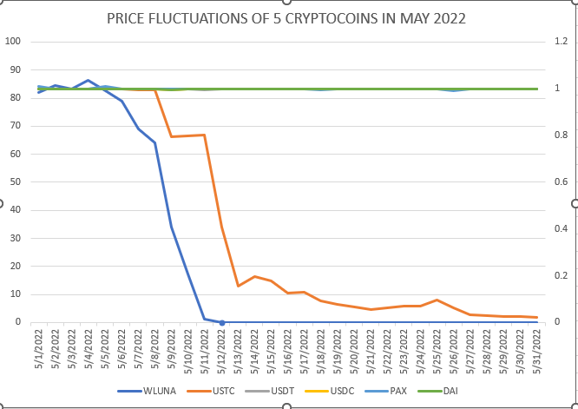

*Price Fluctuations of 6 Crypto Coins In May 2022*

It can be seen that the price of USTC decreased with the decreasing price of WLUNA.

## Homophily Effects in Social Network Prior Crash

The network was tested for any significant homophily effects. In order to model homophily in social network data, where nodes are more likely to be connected to other nodes that have comparable properties, the "nodematch term" in the ergm package is used. The network was constructed using the WWLUNA file available that contained WLUNA data for April ,2022. The tendency for nodes to be connected to other nodes with high out degrees is represented by the nodematch outdegree high term in an ergm model as shown below.

## 

The results from this model showed the coefficient for nodematch to be really small (negative infinity) which means that the results were not significant. Nodes with higher connections were not more likely to be connected to each other prior to crash.

Ergm was used to test for significance of density of the network prior to the crash.

**Null Hypothesis:** Network density was not significant prior crash

**Alternate Hypothesis** : Network density was significant prior crash



The results show that the p value is less than 0.05. Hence, null hypothesis can be rejected. Density of the network was significant prior to the crash.

## Comparison of Network Modularity Before and After Crash

The modularity of data was derived based on the graphs derived from theVincent D Blondel, Jean-Loup Guillaume, Renaud Lambiotte, Etienne Lefebvre, Fast unfolding of communities in large networks, in Journal of Statistical Mechanics: Theory and Experiment 2008 (10), P1000.

The modular communities network representation can be seen in below graphs

*WLUNA network in - April* *WLUNA network in - May*

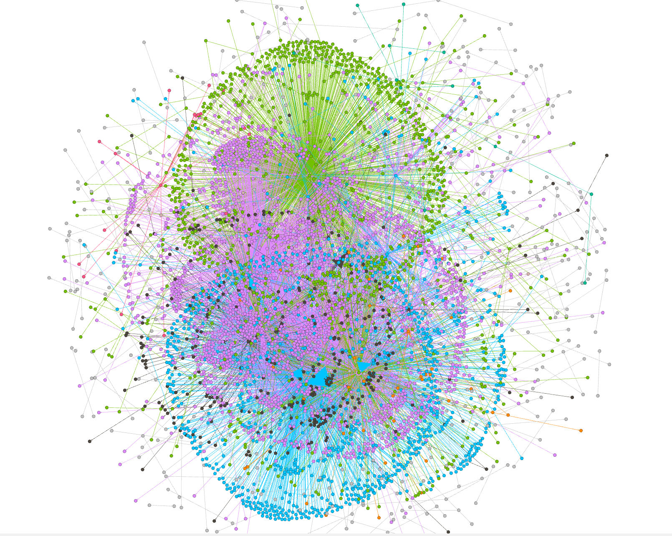

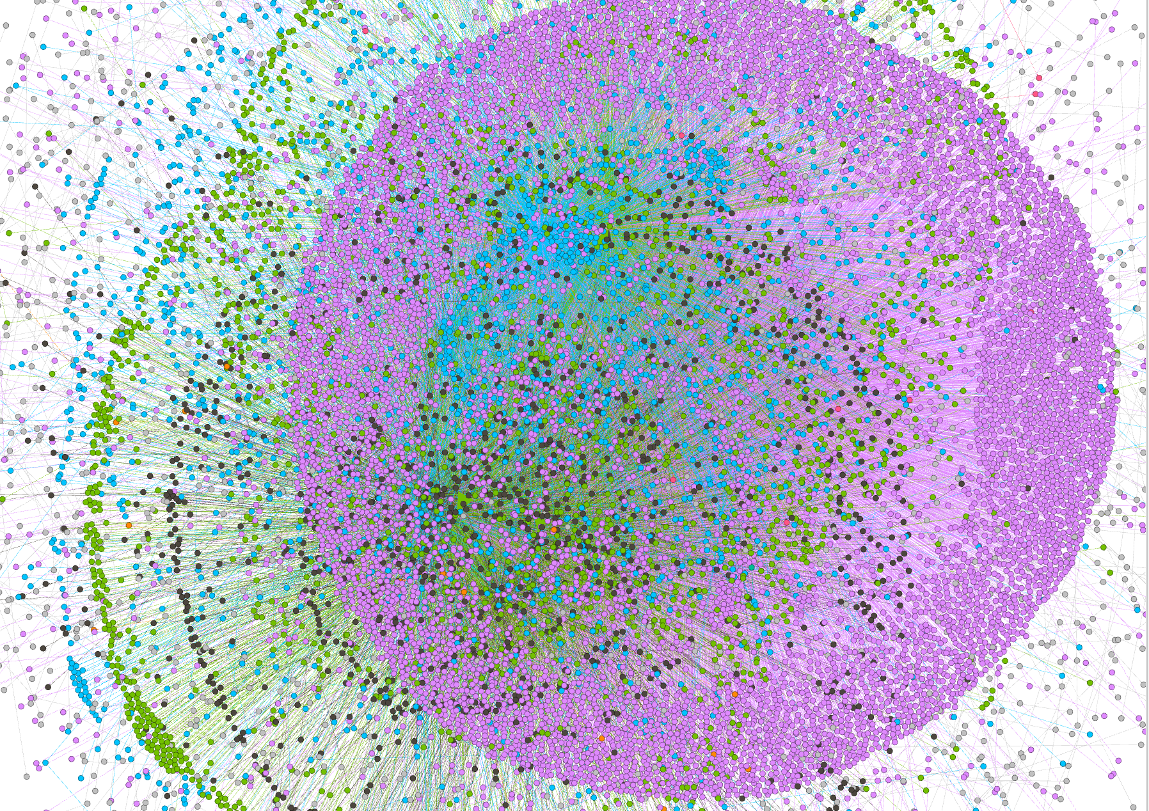 *WLUNA network in - June*

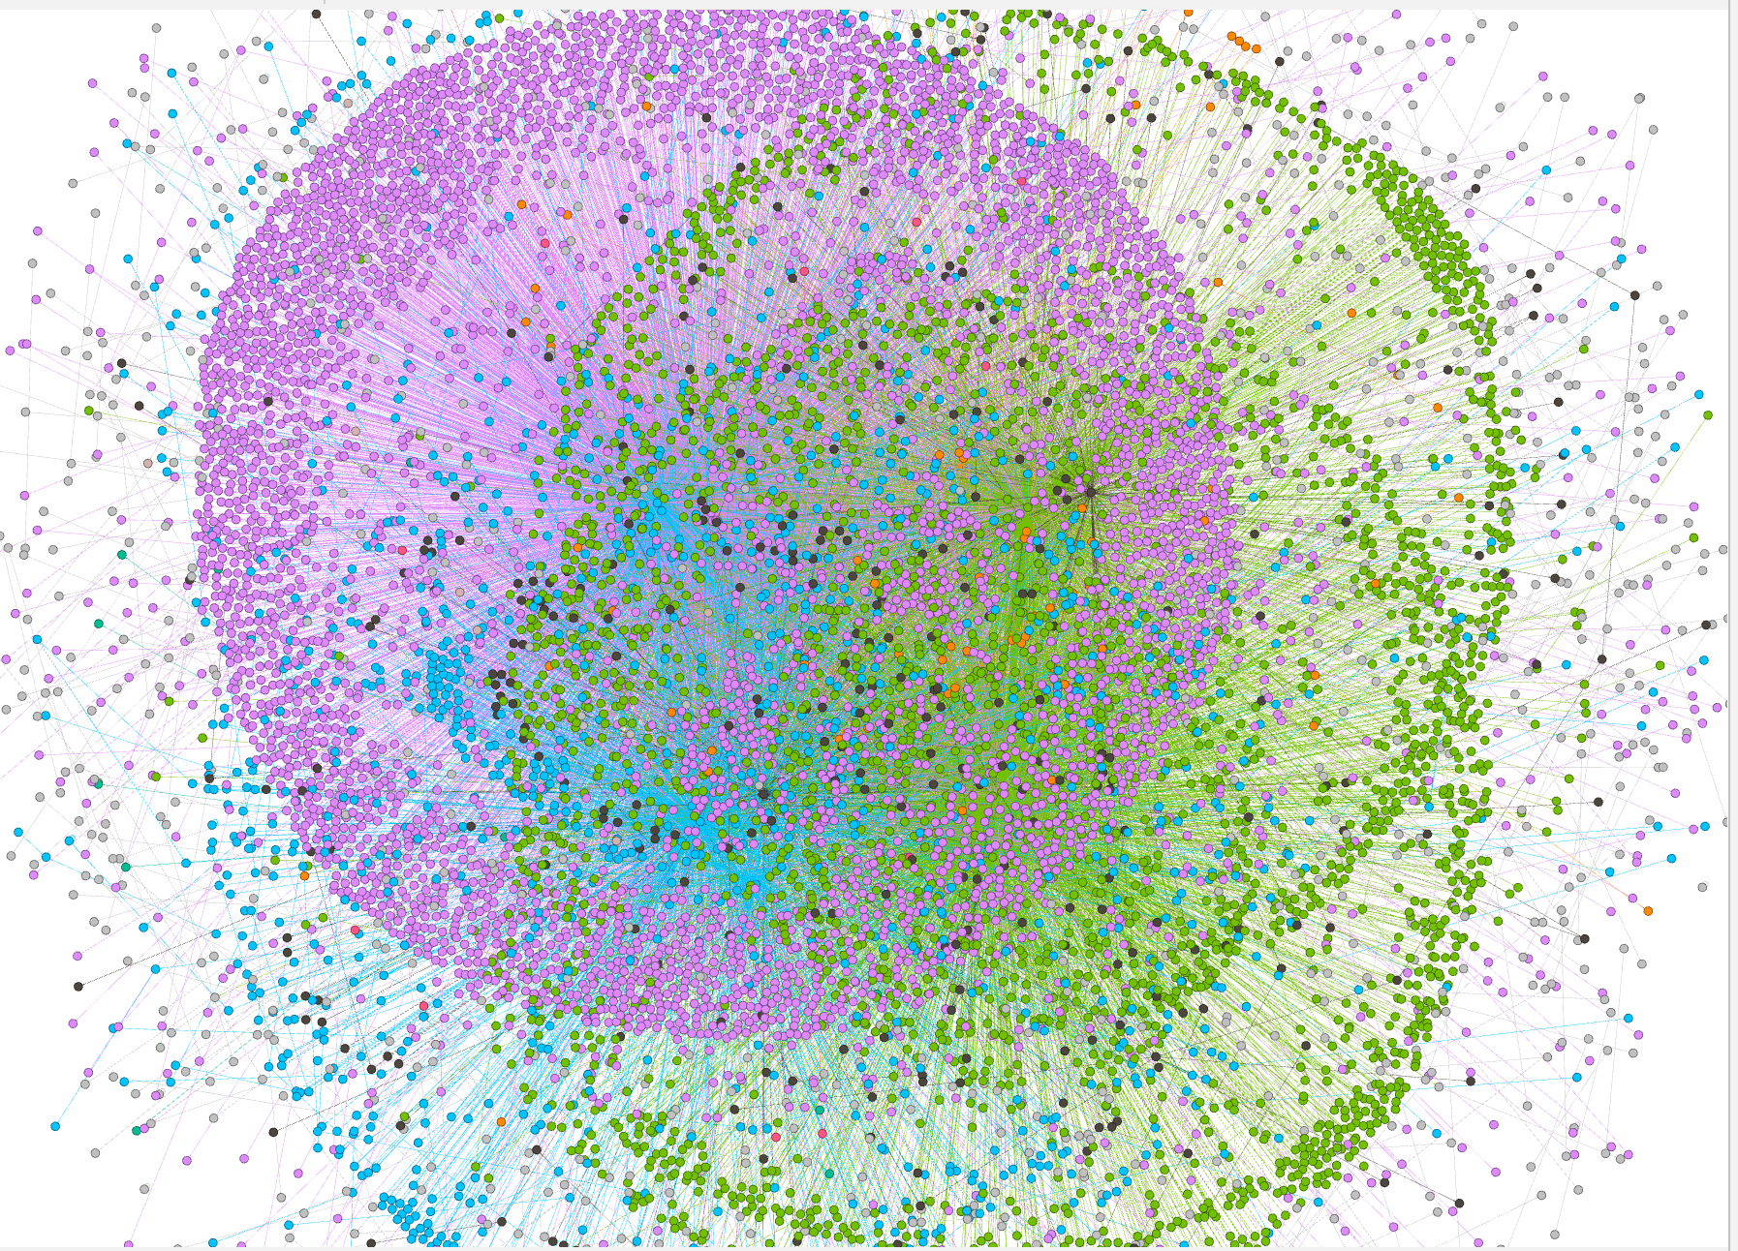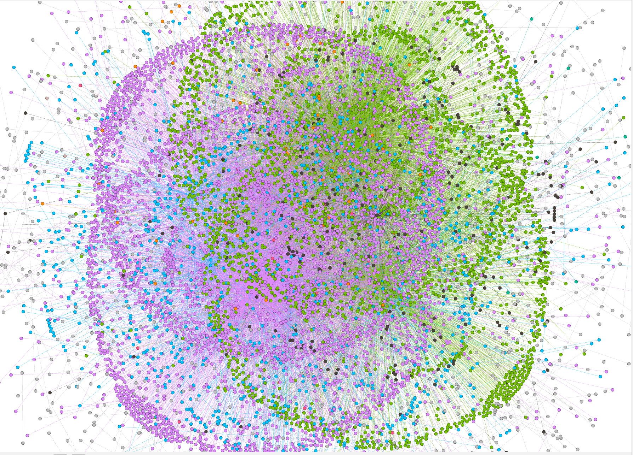

*WLUNA network in - July* *WLUNA network in - August*

Modularity is a measure of how well a network can be divided into distinct groups or communities based on the connections between its nodes. In the case of the WLUNA dataset, higher modularity values suggest that there are tighter-knit communities within the network, with stronger connections within each group and weaker connections between them. This can be a double-edged sword: while higher modularity can indicate a well-organized network with clear subgroups, it can also be a sign of potential market manipulation and instability if a small group of individuals controls the network.

In the WLUNA dataset, the modularity values for all the months are relatively high, indicating the presence of well-defined communities within the network. However, the number of communities detected varies widely across the different months. For example, the number of communities detected in May onwards is much higher than in April, suggesting that there may have been more fragmentation within the network during these months.

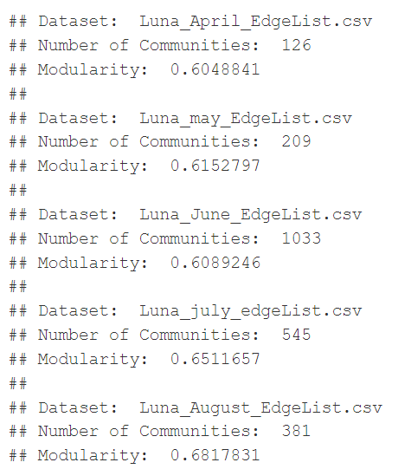

Number of Communities & Modularities for each month:

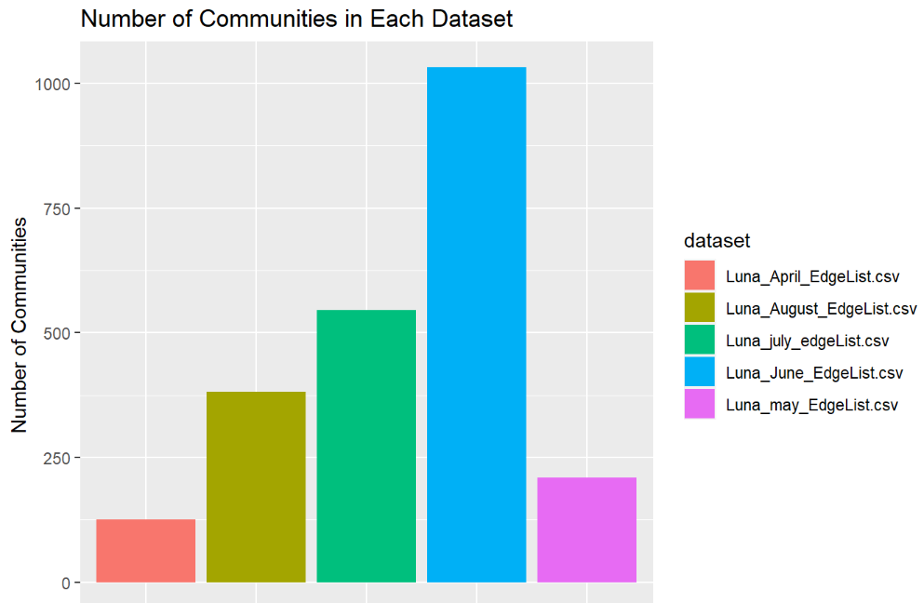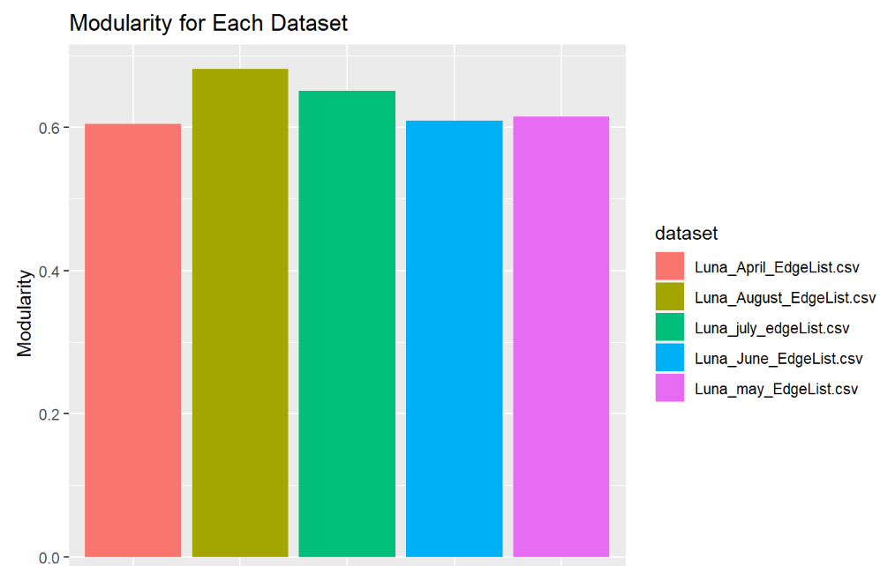

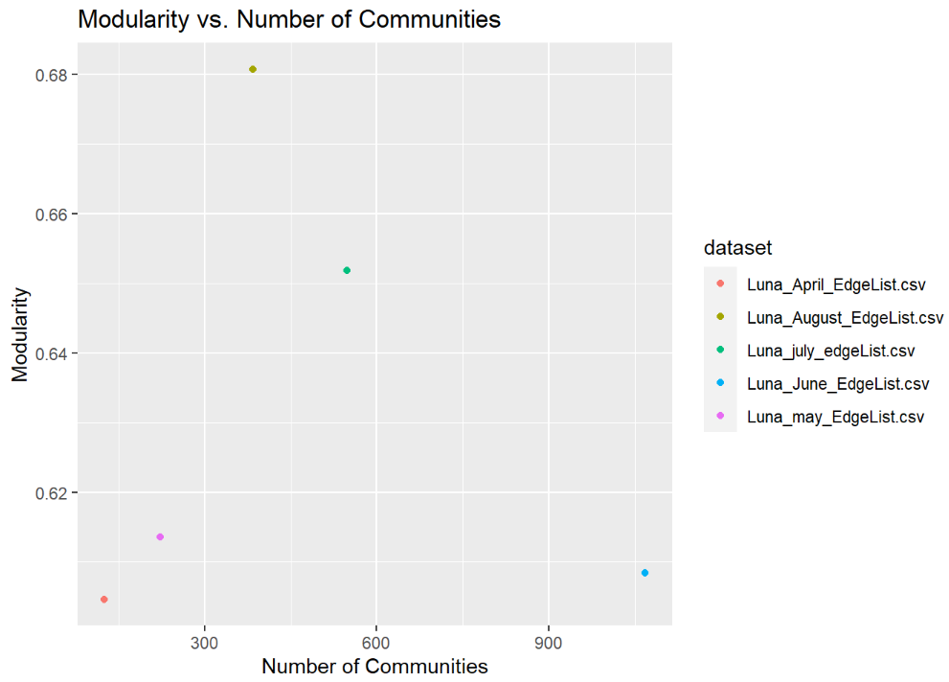

# INTERPRETATION AND RESULTS

All the Network Analysis tends to indicate following observations -

▪A decreasing network density, higher centralization and higher transitivity can be a sign of an upcoming crash creating a “domino effect” in the network

▪The network is most centralized when the WLUNA price reaches close to zero causing a significant fraction of transactions to be done by a group of users. With the key players in the network coming together, the network, insider trading starts with the groups of individuals. This panic selling results in a drastic decrease in price of a coin.

▪Modularity of network does vary across the months but there is not a significant difference in modularities before and after crash. Hence, it can not be a deciding factor for the crash

▪In future if the value of a USTC increases, investors can also think about buying WLUNA to diversify their holdings and possibly boost returns because of high correlation. Similarly, a decrease in USTC price can account for a further decrease in WLUNA price.